# HOW TO APPLY: -

* 1. Application shall be neatly typed/ filled in the prescribed format enclosed herewith.
  2. Self-attested copies of all the required documents in support of age, sports achievements, EWS certificate and Undertaking shall be attached.
  3. Applications complete in all respects and duly signed by the applicant be placed in a sealed envelope and sent to

**THE SECRETARY,**

**ZONAL SPORTS PROMOTION COMMITTEE, FOOD CORPORATION OF INDIA,**

**ZONAL OFFICE (WEST),**

**FCI, NEW BUILDING, RAJENDRA NAGAR, DATTAPADA ROAD, BORIVALI (EAST), MUMBAI –400066.**

The envelope shall be addressed with the Title **“APPLICATION FOR AWARD OF STIPEND FOR TALENTED SPORTSPERSONS”.**

**APPLICATION FOR THE AWARD OF STIPEND FOR SPORTSPERSON**

1. Serial No (To be assigned by the office)

Please affix recent Passport size color photograph (self- attested)

1. Sports applied for:

(Please tick the appropriate discipline among the following)

* 1. **BADMINTON**
  2. **TABLETENNIS**
  3. **CRICKET**
  4. **HOCKEY**
  5. **FOOTBALL**
  6. **SWIMMING**

1. Gender
2. Name in full

|  |  |  |  |  |  |  |  |  |  |  |  |  |  |  |  |  |  |  |  |  |  |  |  |  |
| --- | --- | --- | --- | --- | --- | --- | --- | --- | --- | --- | --- | --- | --- | --- | --- | --- | --- | --- | --- | --- | --- | --- | --- | --- |
|  |  |  |  |  |  |  |  |  |  |  |  |  |  |  |  |  |  |  |  |  |  |  |  |  |
|  |  |  |  |  |  |  |  |  |  |  |  |  |  |  |  |  |  |  |  |  |  |  |  |  |

1. Father’s name

|  |  |  |  |  |  |  |  |  |  |  |  |  |  |  |  |  |  |  |  |  |  |  |
| --- | --- | --- | --- | --- | --- | --- | --- | --- | --- | --- | --- | --- | --- | --- | --- | --- | --- | --- | --- | --- | --- | --- |
|  |  |  |  |  |  |  |  |  |  |  |  |  |  |  |  |  |  |  |  |  |  |  |
|  |  |  |  |  |  |  |  |  |  |  |  |  |  |  |  |  |  |  |  |  |  |  |

1. Date of Birth 

|  |  |  |  |
| --- | --- | --- | --- |
|  |  |  |  |

Age: Years Months Days

1. Mailing Address

|  |  |  |  |  |  |  |  |  |  |  |  |  |  |  |  |  |  |  |  |  |  |
| --- | --- | --- | --- | --- | --- | --- | --- | --- | --- | --- | --- | --- | --- | --- | --- | --- | --- | --- | --- | --- | --- |
|  |  |  |  |  |  |  |  |  |  |  |  |  |  |  |  |  |  |  |  |  |  |
|  |  |  |  |  |  |  |  |  |  |  |  |  |  |  |  |  |  |  |  |  |  |
|  |  |  |  |  |  |  |  |  |  |  |  |  |  |  |  |  |  |  |  |  |  |
|  |  |  |  |  |  |  |  |  |  |  |  |  |  |  |  |  |  |  |  |  |  |
|  |  |  |  |  |  |  |  |  |  |  |  |  |  |  |  |  |  |  |  |  |  |
|  |  |  |  |  |  |  |  |  |  |  |  |  |  |  |  |  |  |  |  |  |  |

Email Phone Mobile

# . Sports Achievements: -

Only the one best certificate of last three years will be considered for marking the candidate.

|  |  |  |  |  |  |
| --- | --- | --- | --- | --- | --- |
| **Sr.**  **No.** | **Represented** | **Yes/No** | **Year** | **Discipline** | **Achievement** |
| I | A university in the inter University tournament by the University Sports  Board |  |  |  |  |
| II | A combined university team in the National and International Competition |  |  |  |  |
| III | A State in National Competition |  |  |  |  |
| IV | The Country in any International Competition |  |  |  |  |
| V | Any Other (Please specify) |  |  |  |  |

# List of Documents attached (Photo copies only)

1. Age Proof (Certificate of 10th or Birth Certificate etc.)
2. Sports/Performance Certificates
3. Any other relevant certificates.
4. Undertaking
5. EWS certificate if applicable.

# DECLARATION

**Certified that the information furnished above is true and correct to the best of my knowledge and belief. In the event of any information being found false or incorrect at any point of time, my candidature for stipend may be cancelled /terminated without any notice. I also declare that I am a citizen of INDIA by birth/domicile.**

Place:

Date: Signature of the Applicant Name of the Applicant:

# UNDERTAKING

*(For Minors)*

Certified that I…………………………………………………………………………………. Father/Guardian of Shri …………………………………………………who has applied for stipend for sportspersons with Food Corporation of India and (if selected) shall represent FCI from time to time in various sporting events. Further, he/she shall not claim any compensation, damages etc. for injury suffered by him/her while playing in any sporting event. He/she is not recipient of any stipend from other sources/ organization

Signature of Parent /Guardian Name

Address Phone No

# UNDERTAKING

*(For Sportspersons of age group*

*>18)*

Certified that I have

applied for stipend for sportspersons with Food Corporation of India and (if selected) shall represent FCI from time to time in various sporting events. Further, I shall not claim any compensation, damages etc. for injury suffered by me while playing in any sporting event. I am not a recipient of any stipend from other sources/ organization.

Signature of Applicant Name

Address Phone No

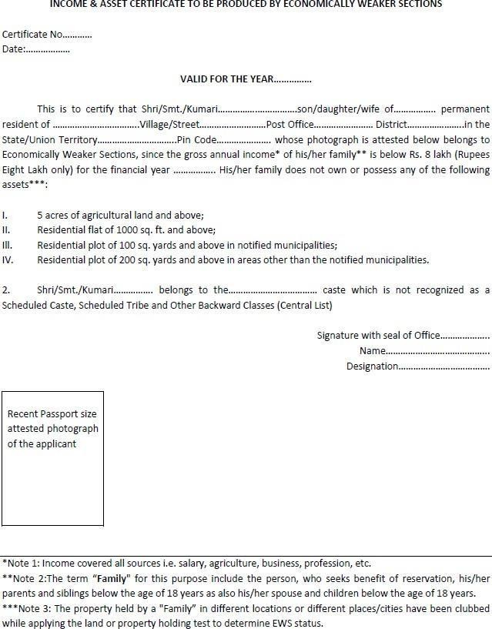

# Note:

The Income and Asset Certificate issued 'by any one of the following authorities in the prescribed format as given above shall only be accepted as proof of candidate's claim as’ belonging to EWS: -

* 1. District Magistrate/Additional District Magistrate/ Collector/ Deputy Commissioner/Additional Deputy Commissioner/ 1st Class Stipendiary Magistrate/ Sub- Divisional Magistrate/ Taluka Magistrate/ Executive Magistrate/ Extra Assistant Commissioner,
  2. Chief Presidency Magistrate/Additional Chief Presidency Magistrate/ Presidency Magistrate,
  3. Revenue Officer not below the rank of Tehsildar and
  4. Sub-Divisional Officer of the area where the candidate and/or his family normally resides.